Modular Pulse Program Generation for NMR Supersequences

Jonathan R. J. Yong,1 Ēriks Kupče,2 Tim D. W. Claridge1,*

1 Chemistry Research Laboratory, Department of Chemistry, University of Oxford, Mansfield Road, Oxford, OX1 3TA, United Kingdom

2 Bruker UK Ltd, R&D, Coventry CV4 9GH, United Kingdom

ABSTRACT: NMR supersequences allow multiple 2D NMR datasets to be acquired in greatly reduced experiment durations through tailored detection of NMR responses within concatenated modules. In NOAH (NMR by Ordered Acquisition using 1H detection) experiments, up to five modules can be combined (or even more when parallel modules are employed), which in theory leads to thousands of plausible supersequences. However, constructing a pulse program for a supersequence is highly time-consuming, requires specialized knowledge, and is error-prone due to their complexity; this has prevented the true potential of the NOAH concept from being fully realized. We introduce here an online tool named GENESIS (GENEration of Supersequences In Silico), available via [https://nmr-genesis.co.uk](https://nmr-genesis.co.uk/), which systematically generates pulse programs for arbitrary NOAH supersequences compatible with Bruker spectrometers. The GENESIS website provides a unified “one-stop” interface where users may obtain customized supersequences for specific applications, together with all associated acquisition and processing scripts, as well as detailed instructions for running NOAH experiments. Furthermore, it enables the rapid dissemination of new developments in NOAH sequences, such as new modules or improvements to existing modules. Here we present several such enhancements, including options for solvent suppression, new modules based on pure shift NMR, and improved artifact reduction in HMBC and HMQC modules.

NMR spectroscopy is one of the most important analytical techniques for the characterization of molecular structures. In particular, *n*‐dimensional (*n*D) NMR experiments provide extensive information about through-bond and through-space connectivity. However, such experiments require the incrementation of one or more indirect-dimension evolution periods, leading to long experiment times. The acceleration of *n*D NMR has therefore emerged as a highly popular area of research: developments in this area include (but are not limited to) ultrafast NMR,[1–4] non‐uniform sampling (NUS),[5–7] multiple‐FID experiments,[4,8–11] and the shortening or elision of recovery delays.[12–15] NOAH (NMR by Ordered Acquisition using 1H detection) experiments,[4,16–24] which fall under the last two categories, consist of a series of multiple 2D experiments (“modules”), combined into one single “supersequence” which uses only one recovery delay for all modules. This provides substantial (up to 4×) time savings compared to conventional acquisition, in which one recovery delay is used per module (Figure 1).

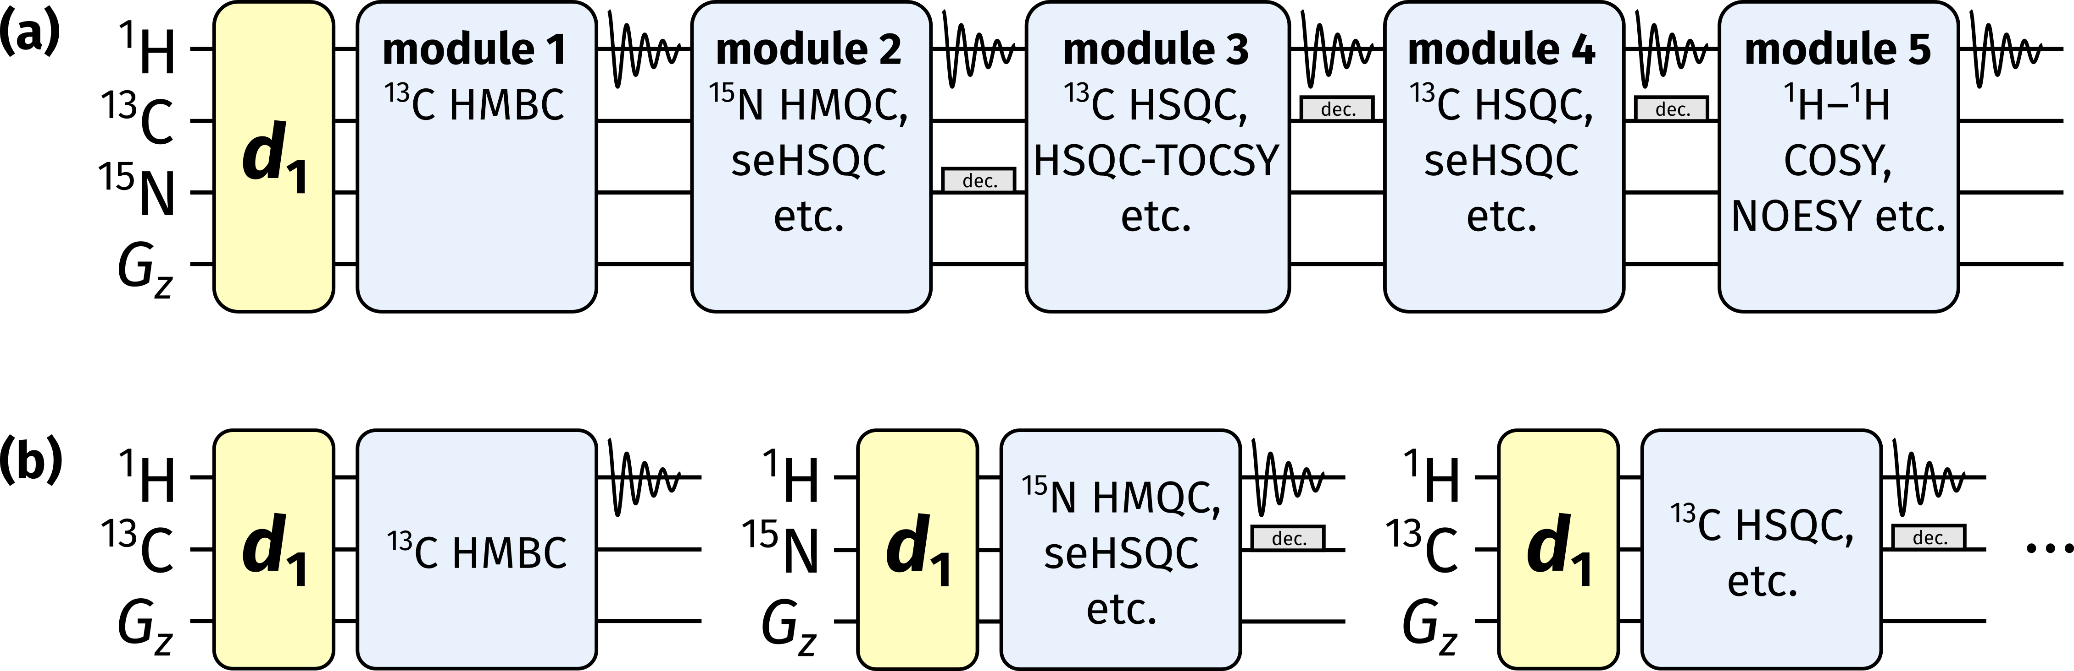

**Figure 1.** (a) Diagrammatic representation of a NOAH supersequence, where only one recovery delay (*d*1) is used for the entire experiment. (b) Conventional 2D NMR data acquisition, where one recovery delay is used per dataset.

Virtually all common 2D experiments employed for small molecule characterization have been implemented in NOAH supersequences to date, including HMBC, HSQC, HSQC‐TOCSY, HMQC, COSY, TOCSY, NOESY, and ROESY. Each module is given a unique abbreviation, usually one letter long (e.g., ‘B’ for HMBC, ‘S’ for HSQC, ‘M’ for HMQC, ‘C’ for COSY) and occasionally sub/superscripted (e.g., ‘ST’ for HSQC‐TOCSY). The combinatorial nature of NOAH experiments means that there are a very large number of conceivable supersequences ranging from NOAH‐2 to NOAH‐5 (where the suffix indicates the number of modules); the use of parallel “*p*-NOAH” supersequences[24] extends this maximum number even further.

For optimal data quality in terms of both sensitivity and artifact minimization, there are certain conditions on NOAH supersequences. Specifically, NOAH modules placed earlier in a supersequence should ideally only excite the magnetization it needs, leaving all other magnetization sources untouched. As an example, in the NOAH‐2 SC supersequence (comprising HSQC and COSY modules), the 1H–13C HSQC module is designed to excite only the 1H nuclei directly attached to the 1.1%‐natural abundance 13C, and leave all other proton magnetization (the “bulk magnetization”) in the equilibrium state, i.e., along the +*z*-axis.[14] A 1H–1H COSY module (or TOCSY, or NOESY, etc.) can then draw on this bulk magnetization, with almost no loss in sensitivity and without having to wait for the 12C‐bound protons to relax. Conversely, if the COSY module were placed first, the 13C‐bound proton magnetization would not survive for use in the HSQC: thus, the HSQC module in a NOAH‐2 CS would display severe sensitivity losses, as compared to in a NOAH‐2 SC. More subtle factors also abound, such as in the SBC sequence,[16] where COSY intensities are modulated by *T*2 relaxation and *J*HH evolution. The alternative BSC arrangement,[17] especially with isotropic “ASAP” mixing applied before the COSY, circumvents this issue and has become the preferred implementation for HMBC/HSQC combinations.[18]

Considerations such as these restrict the set of “viable” NOAH supersequences. Even so, the original NOAH paper alone suggests a figure of 285,[16] and the number of available modules has only grown since then. By our calculations, as of the time of writing, there are 4242 viable NOAH supersequences (Section S1, *Supporting Information*). Although there is a clear blueprint for *how* to construct such supersequences, it is evidently impractical to do all of these “by hand”. Each combination requires its own pulse program, which is typically many hundreds of lines long; this complexity makes pulse program construction highly time-intensive, and makes the chances of errors (such as inconsistent parameter definitions) substantially higher. Consequently, of the thousands of combinations available, only a few dozen “typical” supersequences have been released, representing only a fraction of the possibilities which the NOAH technique offers; these alone are unlikely to adequately meet the varied requirements of users.

To solve this problem, we sought to *programmatically* generate NOAH pulse programs, an approach which we term GENESIS (GENEration of Supersequences In Silico). A programmatic approach not only provides virtually instantaneous results, but also ensures that the output is predictable and can be reasoned about, which eliminates many possibilities of user error during pulse program construction. The modular nature of NOAH supersequences (i.e., having multiple almost-independent components which are pieced together to form a greater entity) lends itself well to this, as each component only needs to be defined once in order to be usable in all combinations. GENESIS is implemented in the form of a single web page (Figure 2), accessible via [https://nmr-genesis.co.uk](https://nmr-genesis.co.uk/), which can construct virtually any supersequence one might want and output a Bruker pulse program ready for download and execution. Apart from allowing users to download customized supersequences, this allows new NOAH developments to be easily and rapidly disseminated to users, independently of Bruker’s own release cycle and without requiring a separate publication for each. Some such enhancements (namely solvent suppression options, new pure shift-based modules, improved versions of HMBC and HMQC modules which minimize spectral artefacts, and various streamlined aspects of acquisition and processing) are detailed later in this article; we anticipate that future feature requests from the NMR community will be similarly implemented.

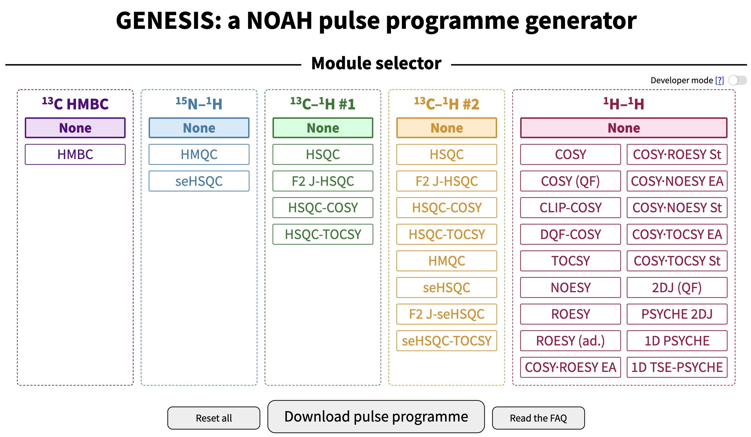

**Figure 2.** A screenshot of the GENESIS web interface. Visible here are the module choices, the “developer mode” toggle, and buttons for downloading the pulse program.

The regular GENESIS user interface is designed to only produce viable supersequences: thus, for example, it is not possible to create the CS or SBC supersequences discussed earlier. This is most useful for users who wish to follow established best practices. For more advanced usage, enabling “developer mode” will remove these limitations, allowing any arbitrary combination of modules to be created. The website further contains an extensive library of frequently asked questions about the implementation and practical details of NOAH experiments. It also offers download links for the AU scripts used for processing, as well as a new Python script used for toggling non‐uniform sampling on or off.

IMPLEMENTATION DETAILS

We begin with a brief discussion of how the GENESIS approach works. The pulse program generation code itself is written in TypeScript (version 4.2.3, Microsoft), which is compiled to JavaScript (formally ECMAScript 2015, or “ES6”) and then executed directly in a client’s web browser. The interface displays a list of modules for users to choose from, using accessible and familiar names such as HMBC, HSQC, and so on (Figure 2). Internally, these are mapped to a series of *NOAHModule* objects, each of which contain module‐ specific information, such as its abbreviation, the requisite parameter definitions, the pulse program for the module itself, and the appropriate AU program to be used for processing.

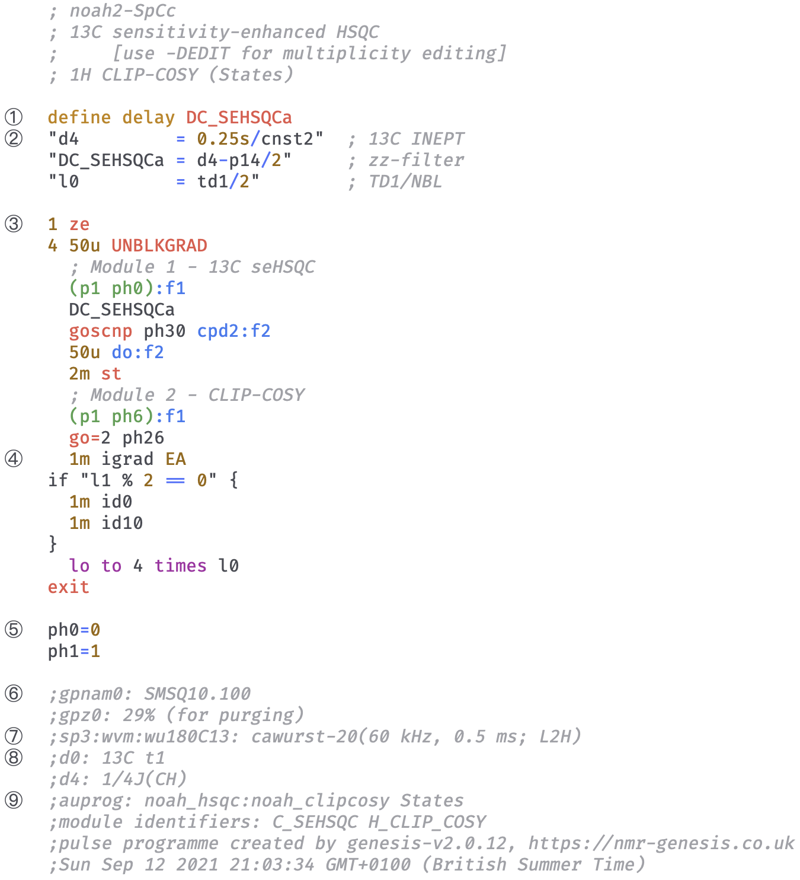

**Figure 3.** Abridged GENESIS pulse program for a NOAH‐2 S+Cc supersequence (13C seHSQC + CLIP‐COSY). Specific sections of interest are numbered on the left. (1) Module‐specific delays are given unique identifiers to prevent clashes and to improve readability. (2) TopSpin parameters (such as the delay *d4*) are standardized between modules. (3) The pulse program instructions begin here. (4) *t*1 incrementation and echo–antiecho gradient inversion is inserted here. (5) Pulse and receiver phase cycles are standardized between modules. (6) Comments for gradient pulses are compatible with the TopSpin *gppp* script. (7) Instructions for generating shaped pulses using TopSpin’s WaveMaker software. (8) Comments describing each parameter appear in the parameter setup screen. (9) Instructions for processing AU programs are encoded here, along with information about the specific modules used and a timestamp which ensures reproducibility.

Using this information, GENESIS then constructs the pulse program in several steps (Figure 3). The pulse program begins with header comments including information about the pulse program and constituent modules. Parameter definitions from each module are then collated, taking particular care to avoid duplicate definitions for parameters used in multiple modules. The main section, which contains the actual instructions for the pulse sequence, is then put together: this is done mostly by concatenating individual modules together, with some context-sensitive blocks such as purge pulses, gradients, or ASAP mixing[18] placed *between* modules. Appropriate looping and incrementation of parameters such as phase cycles, *t*1 delays, and gradient amplitudes for echo–antiecho selection is added at the end of the main section. Following this, additional comments containing descriptive text for parameters (displayed in TopSpin's *ased* parameter setup screen), as well as gradient and shaped pulse information (which allow direct setup using the *gppp* and *wvm* commands), are inserted. Finally, we also specify the exact modules used in the pulse program, the GENESIS version number, and a timestamp: this is important for reproducibility purposes.

An immediate problem of directly concatenating pulse program texts from different sources is that a given parameter from one source may take on a different meaning in another source. To avoid such clashes, we have fully standardized all parameters used in the GENESIS pulse programs. These include pulse widths (*p#*), delays (*d#*), constants (*cnst#*), *z*-gradient amplitudes (*gpz#*), and phase cycles (*ph#*), where *#* represents a non‐negative integer. Where possible, we have chosen meanings that are similar to those in the standard library of Bruker pulse programs, only deviating in order to avoid otherwise inevitable clashes between different modules. Furthermore, in place of module‐specific delays which are often called *DELTA#* in standard library sequences, we have chosen to define new identifiers with more human‐readable names inside the pulse program itself. Thus, the delays in a HSQC sequence might be called *DC_HSQC#*, where the first C indicates the indirect‐dimension nucleus (13C). While this standardization was primarily implemented in order to facilitate pulse program construction, this also makes it far easier for users to set up NOAH experiments. Since the majority of these parameters are consistent with the standard Bruker library, many of them may be directly read in from the *prosol* relation tables and/or existing parameter sets in TopSpin. Furthermore, since every parameter has the same meaning in every NOAH supersequence, it also makes setting up multiple supersequences an almost trivial task: generally, only the parameters *NBL*, *PULPROG*, and *TD1* need be changed.

Another potential issue is that different versions of a pulse sequence often exist. An example is the *zz*-HMBC, where the implementation of the *zz*-filter element depends on whether 13C‐bound and/or 15N‐bound 1H magnetization need to be retained for later modules.[17,19] Since the user only specifies that they want a HMBC module and not the exact details of the *zz*-filter, the GENESIS code must in effect make this choice for the user behind the scenes, in an adaptive fashion which changes depending on what other modules the user selects (Figure 4). Advanced users may, however, circumvent this and make their own choice by entering “developer mode”: each version of the HMBC is assigned a different label *C_HMBC_{LABEL}* (the available labels are enumerated in more detail on the website). The sensitivity‐enhanced HSQC (seHSQC, abbreviated ‘S+’/Sp) presents a similar case. If the seHSQC module is followed by one or more homonuclear modules such as a COSY or NOESY, then the ZIP‐seHSQC[22,23] is automatically chosen, as this version preserves the requisite bulk magnetization for the later modules. However, if the seHSQC module is placed at the end of the sequence, then the original Cavanagh–Rance–Kay seHSQC[25,26] is chosen in order to maximize sensitivity.

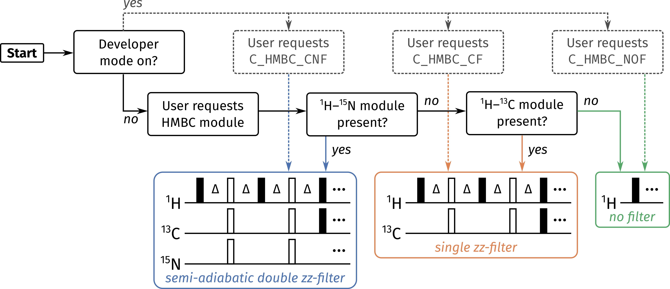

**Figure 4.** Flowchart illustrating how GENESIS decides the form of the *zz*-filter to be used in a 1H–13C HMBC module. Dotted lines represent the branch where developer mode is enabled, i.e., the user has full control over which form is used: these are specified using alphabetical labels of the form *C_HMBC_{LABEL}*. Solid lines represent the standard user mode, i.e., developer mode disabled: in this case, GENESIS automatically chooses the appropriate module based on what other modules are present in the supersequence.

In order to maximize flexibility within a sequence, the GENESIS pulse programs make substantial use of acquisition flags, a feature within TopSpin which allows for conditional compilation of pulse program segments. By defining one or more “symbols” inside the *zgoptns* TopSpin parameter, users may choose whether to include additional features in the pulse program, such as multiplicity editing in HSQC sequences, zero‐quantum suppression,[27] and solvent suppression. The benefit of this is that there is no need for users to store multiple different pulse sequences which only differ in isolated sections.

As a final point for this section, we touch on the issue of reproducibility, which is a key consideration for scientific code such as GENESIS.[28] Although one of the primary aims of GENESIS is to release new updates to NOAH supersequences in a timely fashion, it is also important that old releases of pulse sequences remain available, so that scientific results using these pulse sequences may be reproduced. Furthermore, each release is accompanied by a suite of processing scripts; these may also be modified over time, and to ensure compatibility with the pulse sequences, old versions of the scripts must also be kept available.

To ensure that NMR experiments run with GENESIS pulse programs and scripts are always reproducible, each pulse program and script is marked with a version number (labelled (9) in Figure 3). Old versions of GENESIS may be obtained using the following formula: to access version vX.Y.Z (where X, Y, Z are integers), navigate to the URL https://nmr-genesis.co .uk/X/Y/Z. For example, the release version that accompanies this paper is labelled v2.1.0; this can be accessed at <https://nmr-genesis.co.uk/2/1/0>. While earlier versions are also available and functional, these should be treated as “pre‐release” versions, to be used at the reader’s own risk. As an alternative, the GENESIS code can be obtained from GitHub at <https://github.com/yongrenjie/genesis> and run entirely offline, allowing users to rewind to any desired version. Instructions on how to use this are provided in the repository description.

In its current form, GENESIS is not capable of creating arbitrary pulse sequences; its scope is limited to NOAH supersequences. However, this remains a viable target for the future: instead of combining NOAH modules to form a supersequence, one may instead consider combining pulse sequence elements (e.g., spin echoes, INEPT, zero‐quantum suppression, decoupling, or solvent suppression schemes) to form a pulse sequence. At an even more granular level, individual building blocks (e.g., pulses, delays, gradients) could be strung together to construct a pulse sequence in an interactive fashion.

NEW NOAH IMPROVEMENTS IN GENESIS

We now detail a few recent improvements to NOAH supersequences, all of which are already implemented in the live GENESIS webpage. It is worth emphasizing that the modular nature of GENESIS means that the addition of a new module enables the creation of all possible supersequences containing that module (of which there may be hundreds); traditionally, only around five of these might have been included with a publication. Likewise, simply changing the underlying code for any existing NOAH module is sufficient to immediately propagate changes to every relevant supersequence.

**13C HMBC module.** The *zz*-HMBC module is ordinarily placed first in a supersequence, where the *zz*-filter element serves to preserve magnetization of protons directly coupled to 13C and/or 15N.[17,19] Specifically, the *zz*-filter acts as a 90° excitation pulse on 12C‐bound protons, while leaving 13C‐bound protons along +*z*. This is largely accomplished in practice, as evidenced by the fact that the intensities in subsequent HSQC‐type modules are barely perturbed. However, due to instrumental imperfections and/or J‐coupling mismatch, not all of the 13C–bound 1H magnetization is perfectly retained: in particular, the *zz*-filter also generates a degree of antiphase magnetization of the form H*x*C*z*. This antiphase magnetization is later refocused during the low‐pass J‐filter (LPJF) to give in‐phase magnetization, eventually ending up as one‐bond correlation artifacts in the HMBC spectrum (Figure 5b).

A simple solution to this is to add a 13C 90° pulse at the end of the *zz*-filter (Figure 5a): this converts any antiphase magnetization to double‐ or zero‐quantum magnetization, which is subsequently dephased by the LPJF. This idea has previously been used by Luy and coworkers in CLIP‐HSQC experiments to remove antiphase contributions prior to FID detection.[29] In the event, this small modification proved to have a large impact, almost completely suppressing the 1*J*CH artifacts (Figure 5c). Further comparisons of artifact intensity are provided in Section S2 of the *Supporting Information*.

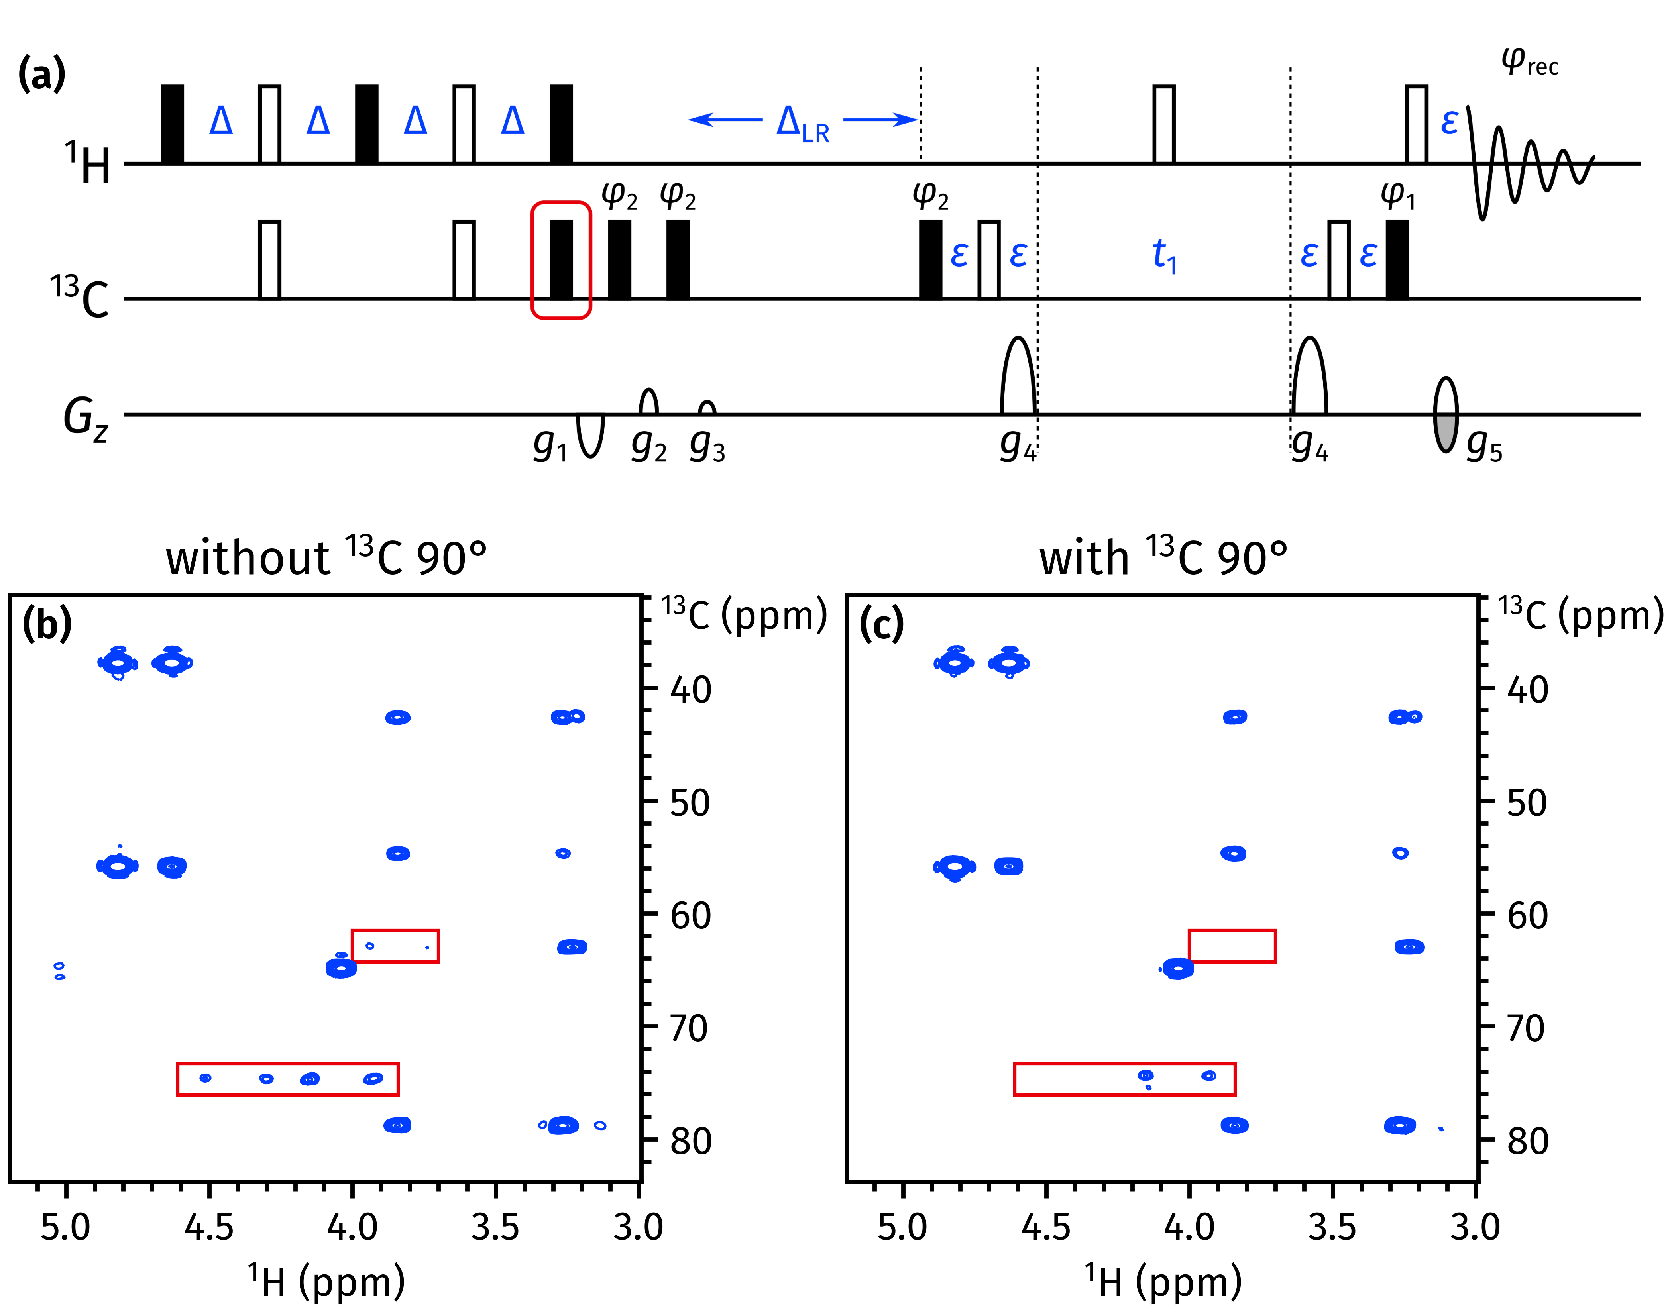

**Figure 5.** (a) The NOAH *zz*-HMBC pulse sequence, with the newly added 13C 90° pulse highlighted in red. The delays are Δ = 1 / (4 · 1*J*CH) and ΔLR = 1 / (2 · *nJ*CH); *ε* is the minimum time required for a gradient plus the subsequent recovery delay. Phase cycling is performed as follows: *φ*1 = *x*, −*x*; *φ*2 = *x*, *x*, −*x*, −*x*; *φ*rec = *x*, −*x*, −*x*, *x*. All gradients have duration 1 ms; amplitudes as a fraction of the maximum gradient strength (55.7 G/cm) are as follows: *g*1 = −15%; *g*2 = 10%; *g*3 = 5%; *g*4 = 80%; *g*5 = ±40.2%. (b) HMBC spectrum obtained using the original *zz*-HMBC module, i.e. without the added 90° pulse. 1*J*CH artifacts are highlighted in red boxes. (c) HMBC spectrum obtained with the added 90° pulse. Spectra were obtained on a 700 MHz Bruker AV III equipped with a TCI H/C/N cryoprobe; the sample used was 40 mM andrographolide in DMSO-*d*6.

**15N HMQC module.** We have recently described the occurrence of “wing artifacts” in homonuclear modules, which arise from bulk magnetization which evolves during either half of *t*1 in a preceding *heteronuclear* module such as a HMQC.[23] These artifacts can be removed in an elegant manner by ensuring that each half of *t*1 in the heteronuclear module contains coherence transfer pathway (CTP) gradients of equal sign and magnitude, which makes sure that any bulk magnetization undergoing net evolution during *t*1 is dephased. At the same time, it is also important that the final gradient in the heteronuclear module have as large an amplitude as possible, since this gradient is responsible for dephasing bulk magnetization that is not returned to +*z* just prior to the detection period. To accomplish this, the previous 15N HMQC module used bipolar opposing gradients in either half of *t*1, a scheme which allows the final refocusing CTP gradient *g*2 to have an amplitude of 4*g*1*γ*N/*γ*H (Figure 6b). Although this leads to excellent artifact suppression in the 15N HMQC itself, wing artifacts are apparent in downstream modules (Figure 6d), because the opposing gradients cancel each other out and do not enforce any CTP selection on the bulk magnetization.

In order to suppress these “wing artifacts” in later modules, it proves better to only use two gradients during *t*1 (one in either half), and to lengthen their duration such that the final gradient *g*2 provides sufficient coherence selection in the HMQC itself (Figure 6c). This strategy was previously described for the 15N seHSQC;[23] here we have also applied it to the HMQC with success (Figure 6e). This change causes no significant difference in the sensitivity of the HMQC module itself (Figure S3).

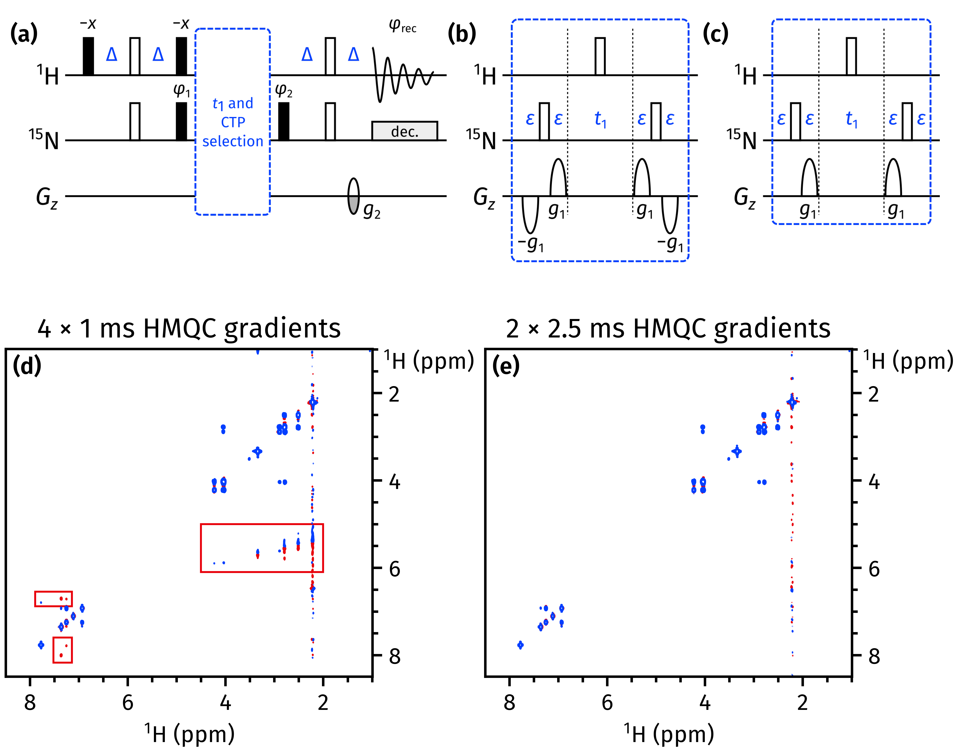

**Figure 6.** (a) A general outline of the NOAH 15N HMQC module. *g*2 has a duration which matches that of *g*1 (explained in the text), and an amplitude of ±*n* · 8.1%, where *n* is the number of CTP gradients bracketing the *t*1 period. *g*1 has an amplitude of 80% in all cases. All other symbols have the same meaning as in Figure 5. (b) The previously published coherence selection scheme for the HMQC module, with four gradients each of duration 1 ms. (c) The new coherence selection scheme for the HMQC module, with two gradients each of duration 2.5 ms. (d)–(e) CLIP‐COSY spectra obtained from a NOAH‐3 MS+Cc supersequence (15N HMQC + 13C seHSQC + CLIP‐COSY), using the gradient schemes shown in (b) and (c) respectively in the HMQC module. The wing artifacts in the former spectrum are highlighted in red boxes. Spectra were obtained on a 700 MHz Bruker AV III equipped with a TCI H/C/N cryoprobe; the sample used was 50 mM zolmitriptan in DMSO-*d*6.

**Pure shift and 2D J modules.** In previous work,[23] we described how 1H–15N modules could be implemented with optional “*k*-scaling”.[30] This entails a reduction in the number of *t*1 increments (by a factor of *k*), in return for a corresponding increase in the number of transients per increment, with no overall change in the experimental time. In particular, for the HMQC experiment, this allowed modest gains in sensitivity as *J*HH splittings were no longer resolved in the indirect dimension.

A simple extension of this protocol to homonuclear 1H–1H modules enables experiments such as 2D J‐resolved or pseudo‐2D pure shift spectroscopy to be incorporated into NOAH supersequences. In both cases, the number of *t*1 increments needed (16–32) is far smaller than the typical number required for a 2D experiment (128–256). In particular, at present, we have implemented a family of PSYCHE experiments, namely: the original pseudo‐2D PSYCHE (abbreviated “P”); the triple spin echo (TSE)‐PSYCHE experiment (“PT”), which provides improved robustness towards strong coupling; and the PSYCHE 2DJ experiment (“J”) which yields pure absorption‐mode lineshapes.[31–33] On top of this, there is also a magnitude‐mode 2D J module available (“Jqf”).

In PSYCHE spectra, the flip angle of the chirp or saltire pulses used in the J‐refocusing element provides the experimentalist with a choice: a larger flip angle provides greater sensitivity, but at the cost of increased artifacts.[33] One advantage of acquiring PSYCHE spectra in NOAH‐ type supersequences is that the increased number of transients compensates for the sensitivity losses inherent to PSYCHE and other pure shift techniques. Thus, the user can choose a smaller flip angle (ca. 10°) in order to maximize spectral purity instead, while not losing any actual spectrometer time. An example of a NOAH‐3 supersequence with the TSE‐PSYCHE module is shown in Figure 7.

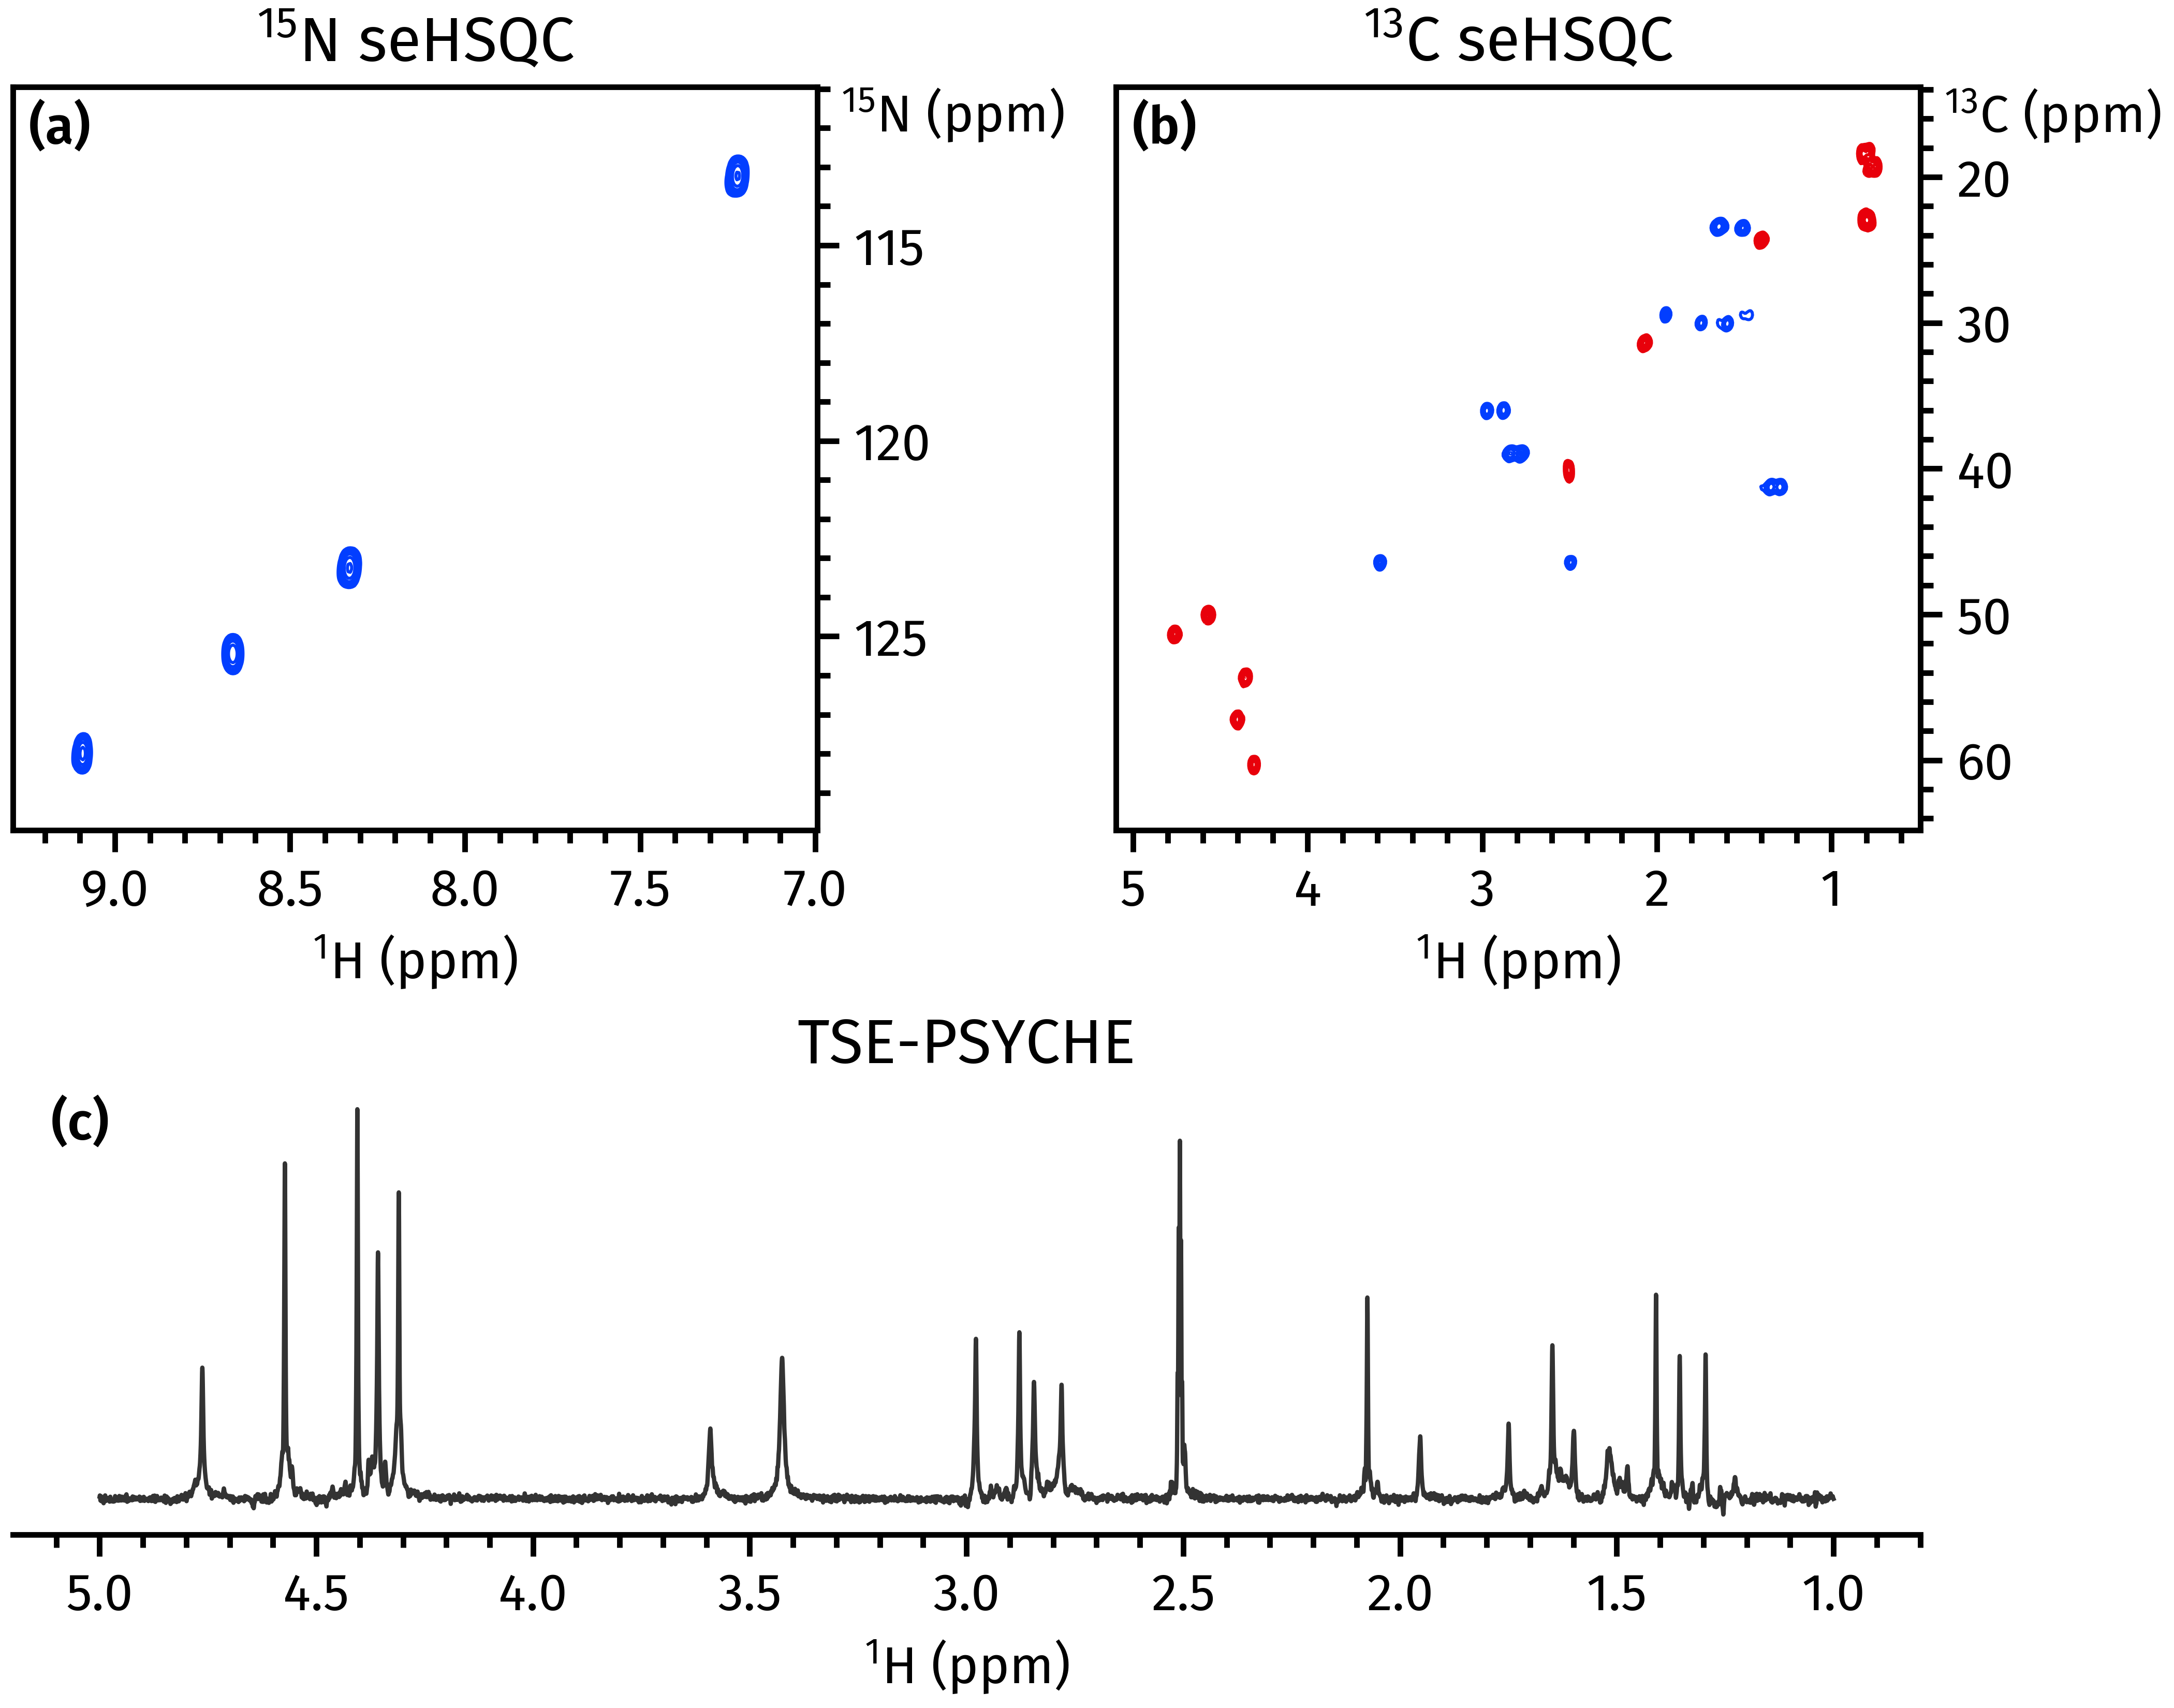

**Figure 7.** Spectra obtained from a NOAH‐3 S+NS+PT supersequence. (a) 15N sensitivity‐enhanced HSQC[23] (256 *t*1 increments, 2 scans per increment). (b) 13C sensitivity‐enhanced HSQC[22,23] (256 *t*1 increments, 2 scans per increment). (c) 1D TSE‐PSYCHE pure shift spectrum[31] (saltire flip angle of 10°, 32 chunks, 16 scans per chunk). Spectra were obtained on a 700 MHz Bruker AV III equipped with a TCI H/C/N cryoprobe; the sample used was 40 mM gramicidin in DMSO-*d*6.

**Solvent suppression.** The addition of solvent suppression to NOAH supersequences is more involved than for a typical NMR experiment, because the water signal must be adequately suppressed in all modules, ideally without affecting any other magnetization components. The HMQC‐ and HSQC‐type NOAH modules in fact provide good intrinsic solvent suppression, because the magnetization of all 1H spins not coupled to heteronuclei—including that of water—are returned to +*z* at the end of the sequence. However, other modules require the addition of specific solvent suppression techniques.

Two options are currently available, namely presaturation (during the recovery delay *d*1, as well as the mixing time in NOESY modules), and excitation sculpting placed just prior to acquisition in homonuclear (1H–1H) modules.[34] The refocusing element used in the latter is a combination of a shaped and hard 180° pulse. Both presaturation and excitation sculpting can be independently turned on or off using the *-DPRESAT* and *-DES* acquisition flags in TopSpin respectively.

***splitx_au* processing.** NOAH data processing is done using the *splitx_au* AU program; this is responsible for creating separate datasets containing the data for each module, defining any required processing parameters, and processing each dataset using module‐specific AU programs (e.g., *noah_hsqc* for 13C HSQC data). Previously, the names of the module‐specific AU programs had to be manually specified as the *USERP#* series of processing parameters. In contrast, with GENESIS pulse programs, this information is directly embedded within the pulse program itself; furthermore, we have modified the *splitx_au* AU program to obtain the requisite list of AU programs by parsing the pulse program text. Users therefore no longer need to provide the *USERP#* parameters, which makes setting up multiple different supersequences a much smoother process. If necessary, it is possible to override these preselected AU programs by explicitly specifying the *USERP#* parameters, allowing for customized processing.

**Non-uniform sampling.** With the GENESIS pulse programs we also introduce a new and more user‐friendly implementation of non‐uniform sampling (NUS). NOAH experiments do not work “out of the box” with TopSpin’s conventional NUS setup routine: some special adjustments must be made by manually generating the list of increments to be sampled and adjusting the *t*1 delays accordingly within the pulse sequence looping. Previously, this was accomplished using a Python script which created a new pulse program for each supersequence, e.g., *noah3_BSC.nus*.[18] We have modified this approach such that NUS is instead controlled by an acquisition flag *-DNUS*, with the benefit that the same pulse program can be used for both uniform and non‐uniform sampling. Although a (different) Python script is still required for initialization, this means that it is no longer necessary to keep two separate instances of the same pulse sequence in TopSpin, thus simplifying the usage of NUS in NOAH supersequences.

CONCLUSION

In this article, we have demonstrated how the modular nature of NOAH supersequences can be exploited in the systematic generation of pulse programs containing any arbitrary set of constituent modules. This provides a real, practical way to obtain the myriad of possible supersequences which have been hitherto inaccessible. Users can create customized sequences which are tailored to their needs, and also access newly implemented or improved modules immediately upon release. Here, we have described several such enhancements, including built-in solvent suppression flags, new pure shift and 2D J modules, the reduction of artifacts in HMBC and HMQC modules, and improved processing routines. All of these, as well as any future updates, are and will be available via the GENESIS website ([https://nmr-genesis.co.uk](https://nmr-genesis.co.uk/)).

ASSOCIATED CONTENT

Supporting Information

The Supporting Information is available free of charge on the ACS Publications website.

Detailed analysis of NOAH combinations and comparisons of pulse sequences (PDF)

AUTHOR INFORMATION

Corresponding Author

Tim D. W. Claridge — *Chemistry Research Laboratory, Department of Chemistry, University of Oxford, 12 Mansfield Road, Oxford, OX1 3TA, United Kingdom*

Email: tim.claridge@chem.ox.ac.uk

Authors

Jonathan R. J. Yong — *Chemistry Research Laboratory, Department of Chemistry, University of Oxford, 12 Mansfield Road, Oxford, OX1 3TA, United Kingdom*

Ēriks Kupče — *Bruker UK Ltd, R&D, Coventry CV4 9GH, United Kingdom*

ACKNOWLEDGMENT

We thank Dr Mohammadali Foroozandeh (University of Oxford) for helpful discussions. J.R.J.Y. thanks the Clarendon Fund (University of Oxford) and the EPSRC Centre for Doctoral Training in Synthesis for Biology and Medicine (EP/L015838/1) for a studentship, generously supported by AstraZeneca, Diamond Light Source, Defence Science and Technology Laboratory, Evotec, GlaxoSmithKline, Janssen, Novartis, Pfizer, Syngenta, Takeda, UCB, and Vertex.

REFERENCES

(1) Frydman, L.; Scherf, T.; Lupulescu, A. The acquisition of multidimensional NMR spectra within a single scan. *Proc. Natl. Acad. Sci. U. S. A.* **2002**, *99*, 15858–15862.

(2) Frydman, L.; Lupulescu, A.; Scherf, T. Principles and Features of Single‐Scan Two‐Dimensional NMR Spectroscopy. *J. Am. Chem. Soc.* **2003**, *125*, 9204–9217.

(3) Tal, A.; Frydman, L. Single‐scan multidimensional magnetic resonance. *Prog. Nucl. Magn. Reson. Spectrosc.* **2010**, *57*, 241–292.

(4) Kupče, Ē.; Frydman, L.; Webb, A. G.; Yong, J. R. J.; Claridge, T. D. W. Parallel nuclear magnetic resonance spectroscopy. *Nat. Rev. Methods Primers* **2021**, *1*, 27.

(5) Mobli, M.; Hoch, J. C. Nonuniform sampling and non‐Fourier signal processing methods in multidimensional NMR. *Prog. Nucl. Magn. Reson. Spectrosc.* **2014**, *83*, 21–41.

(6) Kazimierczuk, K.; Orekhov, V. Non‐uniform sampling: post‐Fourier era of NMR data collection and processing. *Magn. Reson. Chem.* **2015**, *53*, 921–926.

(7) Gołowicz, D.; Kasprzak, P.; Orekhov, V.; Kazimierczuk, K. Fast time‐resolved NMR with non‐uniform sampling. *Prog. Nucl. Magn. Reson. Spectrosc.* **2020**, *116*, 40–55.

(8) Nolis, P.; Pérez‐Trujillo, M.; Parella, T. Multiple FID Acquisition of Complementary HMBC Data. *Angew. Chem., Int. Ed.* **2007**, *46*, 7495–7497.

(9) Kupče, Ē.; Freeman, R. Molecular Structure from a Single NMR Experiment. *J. Am. Chem. Soc.* **2008**, *130*, 10788–10792.

(10) Nagy, T. M.; Gyöngyösi, T.; Kövér, K. E.; Sørensen, O. W. BANGO SEA XLOC/HMBC–H2OBC: complete heteronuclear correlation within minutes from one NMR pulse sequence. *Chem. Commun.* **2019**, *55*, 12208–12211.

(11) Nagy, T. M.; Kövér, K. E.; Sørensen, O. W. Double and adiabatic BANGO for concatenating two NMR experiments relying on the same pool of magnetization. *J. Magn. Reson.* **2020**, *316*, 106767.

(12) Schanda, P.; Van Melckebeke, H.; Brutscher, B. Speeding Up Three‐Dimensional Protein NMR Experiments to a Few Minutes. *J. Am. Chem. Soc.* **2006**, *128*, 9042–9043.

(13) Kupče, Ē.; Freeman, R. Fast multidimensional NMR by polarization sharing. *Magn. Reson. Chem.* **2007**, *45*, 2–4.

(14) Schulze‐Sünninghausen, D.; Becker, J.; Luy, B. Rapid Heteronuclear Single Quantum Correlation NMR Spectra at Natural Abundance. *J. Am. Chem. Soc.* **2014**, *136*, 1242–1245.

(15) Nagy, T. M.; Kövér, K. E.; Sørensen, O. W. NORD: NO Relaxation Delay NMR Spectroscopy. *Angew. Chem., Int. Ed.* **2021**, *60*, 13587–13590.

(16) Kupče, Ē.; Claridge, T. D. W. NOAH: NMR Supersequences for Small Molecule Analysis and Structure Elucidation. *Angew. Chem., Int. Ed.* **2017**, *56*, 11779–11783.

(17) Kupče, Ē.; Claridge, T. D. W. Molecular structure from a single NMR supersequence. *Chem. Commun.* **2018**, *54*, 7139–7142.

(18) Claridge, T. D. W.; Mayzel, M.; Kupče, Ē. Triplet NOAH supersequences optimised for small molecule structure characterisation. *Magn. Reson. Chem.* **2019**, *57*, 946–952.

(19) Kupče, Ē.; Claridge, T. D. W. New NOAH modules for structure elucidation at natural isotopic abundance. *J. Magn. Reson.* **2019**, *307*, 106568.

(20) Rao Kakita, V. M.; Hosur, R. V. All‐in‐one NMR spectroscopy of small organic molecules: complete chemical shift assignment from a single NMR experiment. *RSC Adv.* **2020**, *10*, 21174–21179.

(21) Kupče, Ē.; Mote, K. R.; Webb, A.; Madhu, P. K.; Claridge, T. D. W. Multiplexing experiments in NMR and multi‐nuclear MRI. *Prog. Nucl. Magn. Reson. Spectrosc.* **2021**, *124‐125*, 1–56.

(22) Hansen, A. L.; Kupče, Ē.; Li, D.‐W.; Bruschweiler‐Li, L.; Wang, C.; Brüschweiler, R. 2D NMR‐ Based Metabolomics with HSQC/TOCSY NOAH Supersequences. *Anal. Chem.* **2021**, *93*, 6112–6119.

(23) Yong, J. R. J.; Hansen, A. L.; Kupče, Ē.; Claridge, T. D. W. Increasing sensitivity and versatility in NMR supersequences with new HSQC‐based modules. *J. Magn. Reson.* **2021**, *329*, 107027.

(24) Kupče, Ē.; Yong, J. R. J.; Widmalm, G.; Claridge, T. D. W. Parallel NMR Supersequences: Ten Spectra in a Single Measurement. *JACS Au* **2021**, DOI: 10.1021/jacsau.1c00423.

(25) Palmer, A. G., III; Cavanagh, J.; Wright, P. E.; Rance, M. Sensitivity improvement in proton‐detected two‐dimensional heteronuclear correlation NMR spectroscopy. *J. Magn. Reson.* **1991**, *93*, 151–170.

(26) Kay, L. E.; Keifer, P.; Saarinen, T. Pure absorption gradient enhanced heteronuclear single quantum correlation spectroscopy with improved sensitivity. *J. Am. Chem. Soc.* **1992**, *114*, 10663–10665.

(27) Thrippleton, M. J.; Keeler, J. Elimination of Zero‐Quantum Interference in Two‐Dimensional NMR Spectra. *Angew. Chem., Int. Ed.* **2003**, *42*, 3938–3941.

(28) Perkel, J. M. Challenge to scientists: does your ten‐year‐old code still run? *Nature* **2020**, *584*, 656–658.

(29) Enthart, A.; Freudenberger, J. C.; Furrer, J.; Kessler, H.; Luy, B. The CLIP/CLAP‐HSQC: Pure absorptive spectra for the measurement of one‐bond couplings. *J. Magn. Reson.* **2008**, *192*, 314–322.

(30) Pérez‐Trujillo, M.; Nolis, P.; Bermel, W.; Parella, T. Optimizing sensitivity and resolution in time‐shared NMR experiments. *Magn. Reson. Chem.* **2007**, *45*, 325–329.

(31) Foroozandeh, M.; Adams, R. W.; Kiraly, P.; Nilsson, M.; Morris, G. A. Measuring couplings in crowded NMR spectra: pure shift NMR with multiplet analysis. *Chem. Commun.* **2015**, *51*, 15410–15413.

(32) Foroozandeh, M.; Adams, R. W.; Meharry, N. J.; Jeannerat, D.; Nilsson, M.; Morris, G. A. Ultrahigh‐Resolution NMR Spectroscopy. *Angew. Chem., Int. Ed.* **2014**, *53*, 6990–6992.

(33) Foroozandeh, M.; Morris, G. A.; Nilsson, M. PSYCHE Pure Shift NMR Spectroscopy. *Chem. Eur. J.* **2018**, *24*, 13988–14000.

(34) Hwang, T. L.; Shaka, A. J. Water Suppression That Works. Excitation Sculpting Using Arbitrary Wave‐Forms and Pulsed‐Field Gradients. *J. Magn. Reson., Ser. A* **1995**, *112*, 275–279.

Authors are required to submit a graphic entry for the Table of Contents (TOC) that, in conjunction with the manuscript title, should give the reader a representative idea of one of the following: A key structure, reaction, equation, concept, or theorem, etc., that is discussed in the manuscript. Consult the journal’s Instructions for Authors for TOC graphic specifications.

